**Descriptive Statistics**

**Console Sales**

There should be some clarity on how many units the Gamecube sold compared to the competition and how many in each region. The number of copies games sell makes more sense when the number of consoles in the market and the way in which they are distributed is known. A game will never sell more copies than the number of consoles sold (unless some crazy people buy more than one) so we need to first see how many Gamecube consoles were sold and how it compares to the competition, The Playstation 2 and Xbox. The Dreamcast was also part of that console generation, but it was discontinued about six months before the Gamecube came out so I excluded it from my research. Sorry Sega fans.

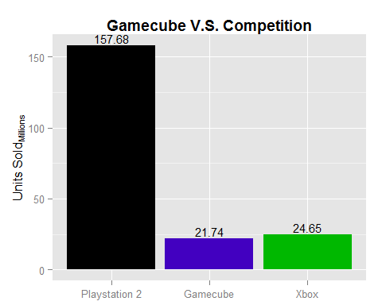

As much as people talk about how the Gamecube didn’t sell well, it wasn’t too far off from the Xbox especially when compared to the Playstation 2. The 22 million that the Gamecube sold is essentially the peak number that a game could potentially sell.

The sales number for each game is also separated by region. So again, the number of consoles sold in a region can be thought of as most a game could potentially sell in that region.

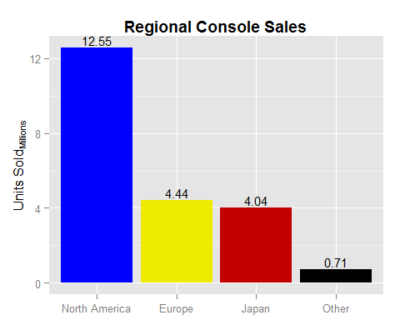

More than half of the consoles sales were in North America with Europe and Japan being almost equal. So when looking at game sales by region, it will be expected that North America sales to make up about half of the total.

With the console’s sales numbers known, we can look into the library of games. The rest of this section will focus on the descriptive statistics for each of the variables.

**Publisher**

The five companies with the most published games are Electronic Arts (92), Nintendo (56), THQ (48), Activision (47), and Konami (41). The yearly releases of FIFA, Harry Potter, Madden, NBA Live, NHL, and The Lord of the Rings games gave EA the edge of Nintendo in publishing games for their own console.

**Genre**

There are 137 sports games and 136 action/adventure games in the Gamecubes library. EA has its yearly releases of sports games, but Konami also contributed many sports games including 10 in the *Jikkyō Powerful Pro Yakyū* series. Action/Adventure makes up a large portion because it’s so open that many games just fall into that genre. Below is the R output for the number of games in each genre.

summary(GCN2$Genre)

## ActionAdventure Collection Fighting Miscellaneous   
## 136 10 43 7   
## Music Party Platformer Puzzle   
## 6 15 80 15   
## Racing RolePlaying Shooter Simulation   
## 75 32 61 11   
## Sports Strategy   
## 137 15

**Release Year**

The most notable aspect of the graph is the drop in support during the year 2004 and again in 2006. The Wii came out in fall of 2006 so it makes sense for the number of games to drop around that time. Nintendo has a history of consoles that lack support from third-party publishers. The drop in support from 2003 to 2004 may be a result of that because they wouldn’t abandon their own console that far in advance of their next one.

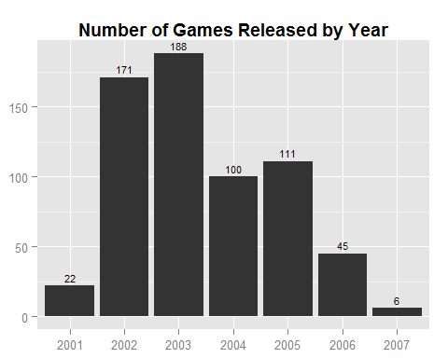

**ESRB Rating**

There is nothing too surprising about the distribution of games by ESRB rating. 304 games were rated Everyone, 34 were rated Everyone 10+, 207 were rated Teen, and 42 were rated Mature. Nintendo’s consoles are branded as being family friendly, yet it still had some M rated games in the library. There were not enough E10 and M rated games for any reasonable analysis so E and E10 games are grouped together while T and M games are grouped together.

**Multiplayer**

There is almost a perfectly even split between one, two, and four player games. 205 games are one-player, 204 are two-player, and 233 are four-player. The only three-player game is *Harry Potter and the Goblet of Fire* (which I grouped with two-player games in my analyses).

**Metacritic Score**

Below is a histogram and summary of the distribution of Metacritic scores. The average review score is 69. The lowest rated game is *Charlie’s Angels* and the highest is *Metroid Prime*. The “NA’s” are games not found on Metacritic.

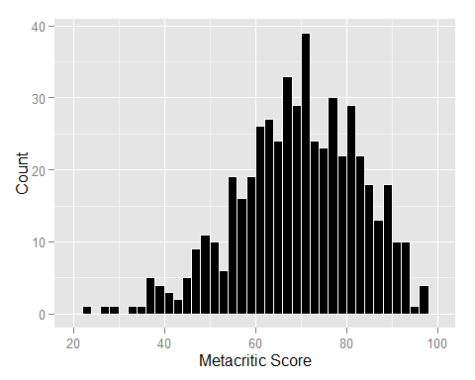

## Min. 1st Qu. Median Mean 3rd Qu. Max. NA's   
## 23.00 61.00 70.00 69.08 79.00 97.00 127

**Exclusivity**

153/643 (23.8%) games are exclusive while the remaining 490/643 (76.2%) games are also available on Xbox and/or PS2. Nintendo published 56 games which will all obviously remain exclusive. So when looking at third-party support, 97/587 (16.5%) are exclusive and the remaining 490/587 (83.5%) are multiplatform.

**Sales**

North America

-Mean sales total: 246,000

-Highest selling game: Super Smash Bros. Melee (4.41 million)

Europe

-Mean sales total: 78,000

-Highest selling game: Mario Kart: Double Dash!! (1.77 million)

Japan

-Mean sales total: 247,000

-Highest selling game: Super Smash Bros. Melee (1.39 million)

Worldwide

-Mean sales total: 356,000

-Highest selling game: Super Smash Bros. Melee (7.07 million)